**A Mini Project Report on**

***“THIRD EYE FOR BLIND”***

Submitted in partial fulfilment for the award of degree

of

**BACHELOR OF ENGINEERING**

in

**ELECTRONICS ENGINEERING**

Under the Guidance of

**Prof. SHIKHA SHARMA**

**Submitted By**

**JISHNU PISHARODY**

**ADITYA RATHOR**

**SAHEB SINGH SANDHU**

**ABHISHEK SINGH**

**DEPARTMENT OF ELECTRONICS ENGINEERING**



**Approved by AICTE, DTE | NAAC Accredited**

**Affiliated to University of Mumbai | ISO 9001-2015 Certified**

**ATHARVA COLLEGE OF ENGINEERING**

**Malad-Marve Road, Charkop Naka, Malad (West), Mumbai-400095**

**ACADEMIC YEAR: 2021-2022**

**ACKNOWLEDGEMENT**

We would like to express our sincere thanks to our guide **Prof. SHIKHA SHARMA** for taking time from his/her busy schedule to provide us with great deal of help, support and encourage us to work diligently at every aspect of our project. His/her views have always been equitable striking a perfect balance between encouragement and constructive criticism. His/her constructive tips and suggestions helped us to successfully do the project. We have benefited a lot from his/her immense knowledge and experience.

We express our sincere gratitude and thankfulness to Dr. S.P. Kallurkar Sir, Principal (ACE), Dr. Bhavin Shah, H.O.D., Department of Electronics Engineering (ACE) and all Staff Members of Department of Electronics Engineering (ACE) who have guided, motivated and supported us for our Mini Project.

We are thankful to the Project Coordinators, Department of Electronics Engineering (ACE), Prof. Akansha Bhargava & Dr. Bhavin Shah, for their valuable suggestions and advice.

Our project at various stages has entailed us to seek help from a variety of individuals, we would like to thank each one of them for their forbiddance and guidance.

Finally we would like to thank our parents and our friends for constantly supporting and encouraging our efforts.

JISHNU PISHARODY(32)

ADITYA RATHOR (35)

SAHEB SINGH SANDHU (37)

ABHISHEK SINGH (41)

**CERTIFICATE**

This is to certify that the **“JISHNU PISHARODY, ADITYA RATHOR, SAHEB SINGH SANDHU & ABHISHEK SINGH,”** of the Department of Electronics Engineering, have submitted the Mini Project Report on ***“THIRD EYE FOR BLIND”*** and are accepted and examined for the partial fulfilment of the Degree of Bachelor of Engineering in Electronics Engineering by the University of Mumbai.



Project Guide H.O.D. Project Coordinator

(Prof. Shikha Sharma ) (Dr. Bhavin Shah) (Prof. Akansha Bhargava

& Dr. Bhavin Shah)

Principal Internal Examiner External Examiner

(Dr. S. P. Kallurkar) (Prof. ) (Prof. )

Date of Examination: __/__/____

**ABSTRACT**

Third eye for blinds is an innovation which helps the blinds people to navigate with speed and confidence by detecting the nearby obstacles using the help of ultrasonic waves and notify them with buzzer sound or vibration. They only need to wear this device as a band or cloth. The intensity of vibration and rate of beeping increases with decrease in distance and this is a fully automated device.

From the survey of WHO, 39 million people are blind all over the world. It is a quite miserable statement. The peoples who are all suffered from these visual difficulties can use this project to overcome their situations. The ultrasonic sensor used in this project plays a vital role. It detects the object in front of this with a certain range. When object is detected a buzzer sound is given to the user as an indication. While they hear this sound they can know an obstacle in front of them.

Keywords : Arduino UNO, buzzer, ultrasonic sensor.

**AIM**

To illustrate the working and construction of “THIRD EYE FOR BLIND”.

**OBJECTIVES**

According to WHO 39 million peoples are estimated as blinds worldwide. They are suffering a lot of hardships in there daily life. So the aim of the project is to develop a cheap and more efficient way to help visually impaired to navigate with greater comfort, speed and confidence.

**TABLE OF CONTENTS**

|  |  |  |
| --- | --- | --- |
| **SR. NO.** | **TOPIC** | **PAGE NO.** |
| 1 | INTRODUCTION | 08 |
| 2 | LITERATURE SURVEY | 09 |
| 3 | COMPONENTS & DESCRIPTION | 10 |
| 4 | BLOCK DIAGRAM | 13 |
| 5 | CIRCUIT DIAGRAM & DESCRIPTION | 14 |
| 6 | SIMULATION AND RESULT | 17 |
| 7 | ADVANTAGES & CHALLENGES | 19 |
| 8 | APPLICATIONS | 20 |
| 9 | CONCLUSION | 21 |
| 10 | FUTURE SCOPE | 22 |
| 11 | REFERENCES | 23 |
| 12 | PROJECT PROGRESS REPORT | 24 |

**LIST OF FIGURES**

|  |  |
| --- | --- |
| **Diagram** | **Page No.** |
| Figure 1: BLOCK DIAGRAM OF THIRD EYE FOR BILND | 13 |
| Figure 2: Circuit Diagram of THIRD EYE FOR BLIND | 14 |
| Figure 3: Simulation of THIRD EYE FOR BLIND | 17 |

**INTRODUCTION**

With the improvement of the expectations for everyday comforts of the individuals, we have become so materialistic that we have overlooked how the physically incapacitated individuals carry on with an intense life. They experience thorough, emotionless and uninterested conduct towards them for being physically incapacitated. They become reliant on other individuals in a manner for their everyday schedule errands. Daze and hindered people consistently rely upon others for their headway. Eye are prime feeling of organ in seeing the outside condition; brokenness of such prime sense organ seriously impacts the information seeing ability of the outside condition. Since the running of daily life of blind people is very difficult. This project helps them to run their life as usual. They can make this project as a gadget or a device in their hands which detects the obstacle. This project is more efficient than the existing system with cheaper and accurate one. Here we are using Arduino UNO board to perform this operation. To make the life to be as a normal one for the blind peoples this may be very helpful project for them. By making this as a gadget or a device in their hand they can easily judge an object by their own by knowing the buzzer sound. The system uses ultrasonic sensor as a wide range of field to detect an object with its higher detection range. Based on this project we take survey in our institution.

**LITERATURE SURVEY**

Have talked about the virtual white stick detecting gadget dependent on dynamic triangulation that can measure separations at a pace of 15 estimations/second. A daze individual can utilize this gadget for detecting nature, pointing it as though it was a blaze light. Alongside estimating separations, this gadget can recognize surface discontinuities, such as the foot of a divider, a stage, or a drop-off. This is gotten by dissecting the range information gathered as the client swings the gadget around, following planar fixes and finding discontinuities. Built up a Nav belt, a deterrent evasion wearable compact PC which is just for indoor route. Nav belt was outfitted with two modes, in the first one the framework data was meant sound in various sounds. One sound for nothing for movement course and other for blocked, it was hard for the individual to separate the sounds. Other issue was the framework would not know the client flitting position. Have portrayed the advancement of a route help so as to help daze and outwardly impeded individuals to explore effectively, securely and to distinguish any obstructions. The framework depends on a microcontroller with engineered discourse yield. Notwithstanding this, the gadget comprises of two vibrators, two ultrasonic sensors which is mounted on the client's shoulders or some other body part and another incorporated into the stick. Has proposed techniques for the outwardly weakened individuals for the urban communities. Be that as it may, they didn't considered about the individuals who can't bear the cost of exorbitant hardware and gadgets. This confinement is overwhelmed by the gadget third eye for the dazzle. Has talked about that the hindrances can be recognized, yet it has numerous restrictions on the points and the separation. On opposite, this undertaking will have a wide edge for the identification where the sensors range will be wide

**COMPONENTS AND DESCRIPTION**

**COMPONENTS REQUIRED:**

• Arduino UNO

• Ultrasonic sensor

• Bread board

• Buzzer

• 5 mm LED: Red

• Slide Switch

• Female Header

• Male Header

• Jumper wires

• Power bank

• Some elastics and stickers

**COMPONENTS DESCRIPTION:**

1. ARDUINO UNO:

The Arduino is an open source hardware and software that can make a user to do effective operation in it. The Arduino is a microcontroller. These microcontroller devices help in sensing and controlling the objects in the real-time situations and environment. These boards are available cheaper in the market. There are a number of inventions performed in it and still it is going on.

2. ULTRSONIC SENSOR:

The ultrasonic sensor consists of transmitter, receiver and transceiver. The transmitter convert electrical signal into soundwaves. The receiver converts the soundwaves into electrical signal again. The transceiver performs both the receiver and transmitter operations. It also has crystal oscillators in it. It will perform the stabilization operation in the ultrasonic sensor.

3. JUMPER WIRE:

The jump wires are also known as jumper wire used to connect devices. Without soldering we can make an easier connection with devices. These are available as a set of wire that has the pin on both sides. These wires are used as making their one end connecting to the corresponding device and another end to the breadboard.

4. PIEZO BUZZER:

The piezo buzzer is an electronic device which generates sound through it. The buzzer is used as an indication to the user. It is used in the car reversing system and braking system as an indication. It is based on the principle of piezoelectricity discovered in 1880 by Jacques and Pierre Curie.

5. ARDUINO SOFTWARE:

The Arduino is the most used programming software to perform the above-mentioned operation. Using some program in the software we can do every operation

**BLOCK DIAGRAM OF THIRD EYE FOR BLIND**

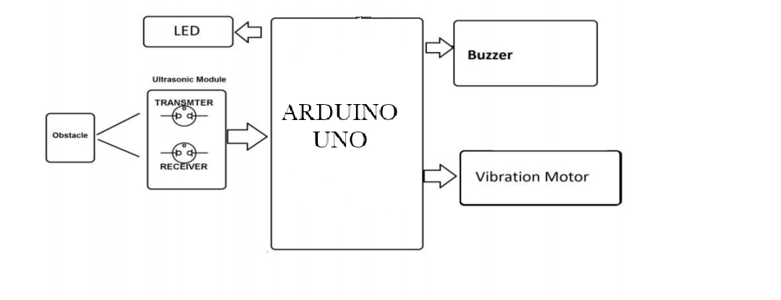

Fig 1. BLOCK DIAGRAM OF THIRD EYE FOR BILND

**CIRCUIT DIAGRAM AND DESCRIPTION**

Fig 2. Circuit Diagram of THIRD EYE FOR BLIND

**DESCRIPTION**

This proposed system consists the equipment like Arduino UNO, ultrasonic sensor, bread board, buzzers for detecting the obstacles and letting the user know about the obstacle, Red LEDs, Switches, Jumper cable, power bank, Male and female header pins, some elastic and stickers to make the device wearable as a band for wearing for the users. The wiring of the device is done in a following manner. The Ground of LED, buzzer are connected to GND of the Arduino. The +ve of the LED and the middle leg of switch is connected to the Arduino pin 5. The +ve of the Buzzer is wired to the first leg of the switch. The Ultrasonic sensor is wired accordingly. The Ultrasonic sensor pin VCC is connected to the Arduino pin VCC, Ultrasonic sensor pin GND is connected to the Arduino pin GND, Ultrasonic sensor pin Trig is attached to the Arduino pin 7, Ultrasonic sensor pin Echo is connected to the Arduino PIN 6. The switch used here is for selecting the mode. (Buzzer should need or not). At the end, after all the connections are done to the Arduino board upload the code to Arduino board and power the other modules using a power bank or the power supply. The Ultrasonic sensor here used as a transceiver. The ultrasonic waves are emitted by the transmitter when the objects are detected. Both the transmitter and receiver re resent inside the ultrasonic sensor. We calculate the time interval between the transmitted and received signal. The distance between the object and sensor is calculated using this. When we increase the distance between the object and the sensor the coverage angle will decrease. Sensor has coverage of 60 degree. Thus, the objective is to cover a wide angle to detect the obstacles with the help of the ultrasonic sensors to help the blind and make it easy for them to move around easily without any hassle. Hence, the distance calculation is calculated and the sensor detects and the further procedure of the buzzing sound to the user is carried out. Thus, this way Third Eye for Blind will be designed for the visually impaired people and will make it very easy and convenient as it will be a wearable device and thus will help the user in travelling and detecting the obstacles while walking very easy.

**SIMULATIONS AND RESULT**

The following simulation was carried on TINKERCAD and it represents the working of THIRD EYE FOR BLIND.

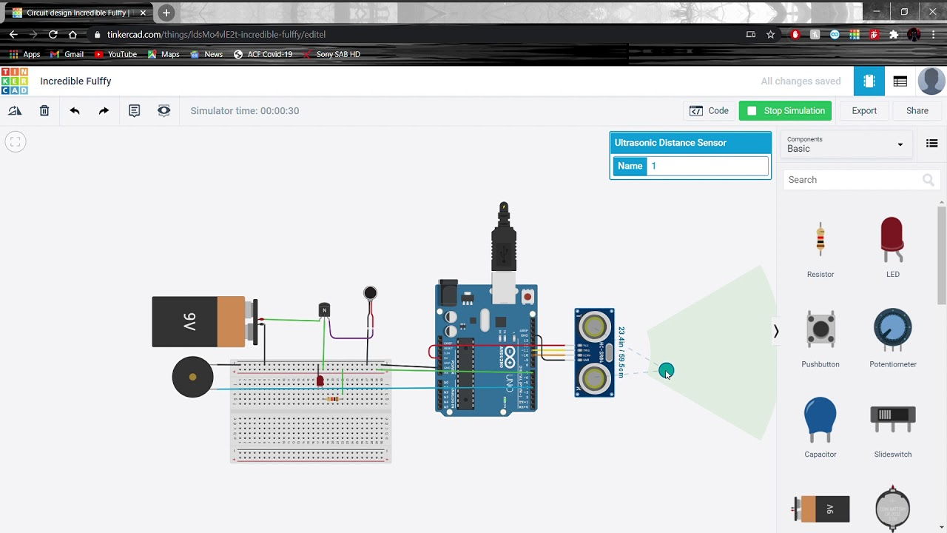

Fig:-3 Simulation for THIRD EYE FOR BLIND

RESULT:

With the improvement of the living standards of the people, we have become so materialistic that we have forgotten how the physically disabled people live a tough life. They undergo rigorous, indifferent behaviour towards them for being physically disabled. They become dependent on other people in a way for their day to day routine chores. Blind and impaired persons always depend on other people for their regular activities. Eyes are responsible for observing and listen the outside environment; dysfunction of such prime sense organ severely affects the knowledge perceiving capability of the outside environment. Therefore, going around to places in such an environment is a very big challenge because blind people cannot depend on their own eyes and thus face many difficulties. This project will help them to overcome their obstacles.

**ADVANTAGES AND CHALLENGES**

ADVANTAGES:

* It can detect objects around a considerably wide range of 11m.
* It is a cost effective project.
* Injuries can be avoided due to this device.
* This system is applicable for both the indoor and outdoor environment.
* Less power consumption.
* Low design time.
* Device is easy for visually impaired people and convenient as it will be a wearable device and thus will help the user in travelling and detecting the obstacles while walking.
* Light weight, so the blind person can carry everywhere, so the person can move anywhere with speed and confidence

**APPLICATIONS**

* + This project is applied mainly in the commercial field of helping visually impaired people with lower eyesight or those that are completely blind.
  + Industrial applications can be devised and enhanced like robots and machineries.
  + Concept can be used for Autonomous cars.
  + Can also be used for security purposes, identifying and tracking objects etc.
  + The third eye for blind is a device, which gives the stick free and comfortable walk to blind people.
  + The blind person can walk with confidence and independently.

**CONCLUSION**

The objective of this project is Third Eye for the Blind is to design a product which is very much useful to those people who are visually impaired and those who often have to rely on others. The third eye for Blind project is an innovation which helps the blind person to move around and go from one place to another with speed and confidence by knowing the nearby obstacles using the help of the wearable band which produces the ultrasonic waves which notify them with buzz sound or vibrations. It allows the user those who are visually impaired to walk freely by detecting the obstacles. They only need to wear this device as a band or cloth on their body. Thus, this project Arduino based obstacle detector for blind people is a new method to resolve their problems. A less complex portable, cost efficient, easy to manage an effective system with many more amazing properties and advantages are proposed to provide support for the blind. The system will be very easy to find the distance between the objects and the sensor. It can detect the objects in every directions the blind person. Without the help of others the blind person can move from one place to other and lead their regular lives independently.

The main purpose of this study is to produce a prototype that can detect objects or obstacles in front of users and feeds warning back, in the form of vibrations, to user.

This project is beneficial for people that are blind, to facilitate the movement and increase safety.

It is a less complex portable, cost efficient, easy to manage an effective system with many more amazing properties and advantages are proposed to provide support for the blind.

**FUTURE SCOPE**

This is the first wearable technology for blinds which resolves all the problems of existing technologies. Now a days there are so many instruments and smart devices for visually impaired peoples for navigation but most of them have certain problems for carrying and the major drawbacks is those need a lot of training to use. The one of the main peculiarity of this innovation is, it is affordable for everyone. There are no such devices available in the market that can be worn like a cloth and having such a low cost and simplicity. When used on a large scale, with improvements in the prototype, it will drastically benefit the community. This device:

- Is the first wearable technology for blinds.

- Uses ultrasonic waves to detect the obstacles

- Notifying the user through vibrations/buzzer sound

**REFERENCES**

* <https://www.electroduino.com/pir-sensor-burglar-alarm-system-circuit-using-555-timer-ic/>
* <https://learn.adafruit.com/pir-passive-infrared-proximity-motion-sensor>
* <https://en.wikipedia.org/wiki/Passive_infrared_sensor>
* <https://www.electronicscomp.com/pir-motion-detector-sensor-module-india>
* <https://hyclassproject.com/design-and-construction-of-third-eye-for-the-blind-using-ultrasonic-sensor.html>
* S. Shovel, I Ulrich, J. Borenstien.Nav Belt and the Guide Cane, IEEE “Transactions on Robotics & Automation”. 2003.
* MA. Espinosa,S. Ungar,E. Ochaíta. “Blades comparing methods for Introducing Blind and Visually Impaired People to unfamiliar urban environments.”, Journal of Environmental psychology. 1998; 18:277-287.
* D. Bolgiano, E. Meeks.” A laser cane for the blind”, IEEE Journal of Quantum Electronics. View at Google Scholar. 1967.

**PROJECT PROGRESS REPORT**

|  |  |  |  |  |
| --- | --- | --- | --- | --- |
| ***Date*** | ***Activity*** | ***Resource***  ***Utilized*** | ***Next***  ***Meet*** | ***Target*** |
| 0/03/2021 | Research of Topic | GOOGLE | /03/2021 | Complete Research Work |
| /04/2021 | Simulation of Project | TINKERCAD | /04/2021 | Complete Simulation |
| /04/2021 | Making of PPT | POWERPOINT | /04/2021 | Completion of PPT |
| /04/2021 | Making of Report | WORD | /04/2021 | Final Submission |